Budget Rent A Car 
of British Columbia

Global Information System

Renter Customer Profile Enhancements

Do Not Rent Customer Enhancement

Customer Information Pre-populate Enhancement

Fraudulent Credit Card Enhancement

Do Not Rent Customer
Apply to: Contract Open/Change during Rental Main Screen; Contract Open/Change during Rental Additional Driver’s screen
We maintain a list of Do Not Rent Customers in our database.
When user enter a customer’s driver licence Number or customer’s name, GIS will check to see if there is any matching to the “Do Not Rent” List.
- One Match found:
- If this is matched by Driver license number, we consider this customer is a “Do Not Rent Customer”, and GIS will go to Cancellation windows Right away. Turn down reason will be pre-set to “Do Not Rent Customer”
- If this is matched by Renter’s First Name and Last Name, GIS will give CSR a warning and CSR will have to check the customer profile carefully, before they deciding to continuing the transaction or not. CSR will have choice to select “Yes” Or “No”
Module Contract Open 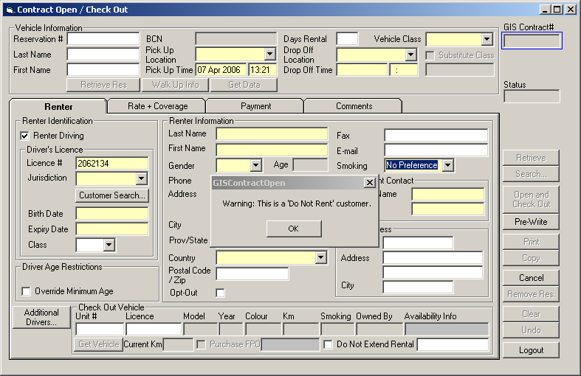
Or Additional Driver
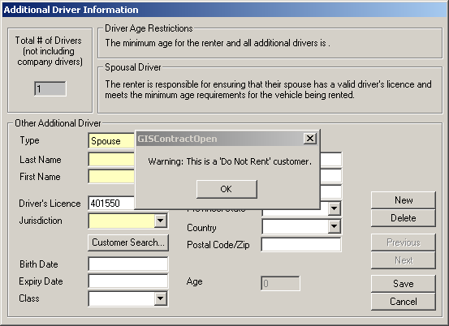

User can check the customer profile here
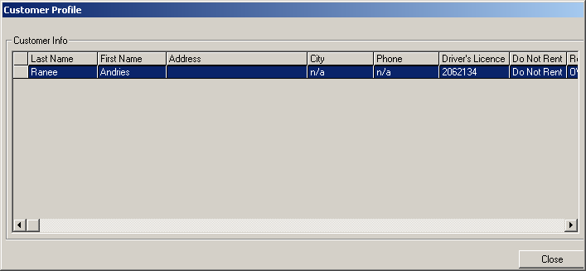
System will prompt User to cancel the transaction after do not rent customer is identified by driver license number
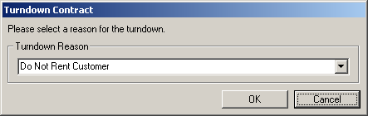
- More than one match found:
  - Matched by Driver License Number:
If all the matches are “do not rent” customers, we consider this customer is a “Do Not Rent Customer”, and GIS will go to Cancellation windows Right away. Turn down reason will be pre-set to “Do Not Rent Customer”
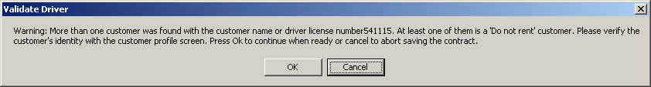
All are do not rent customers in the matching list
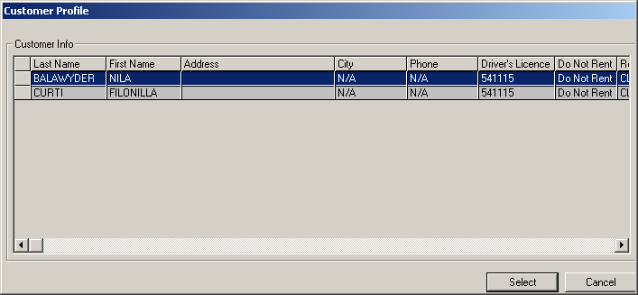

Go to Cancellation Screen right away
If not all the matches are “Don Not Rent” Customers, CSR can check the customer profile and make selections.
  - Matched by Renter’s name:
If all the matches are “do not rent” customers, GIS will give CSR a warning and CSR will have to check the customer profile carefully, before they deciding to continuing the transaction or not. CSR will have choice to select “Yes” Or “No”.
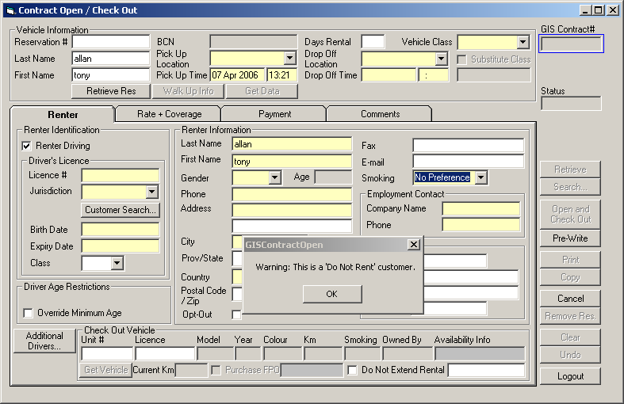

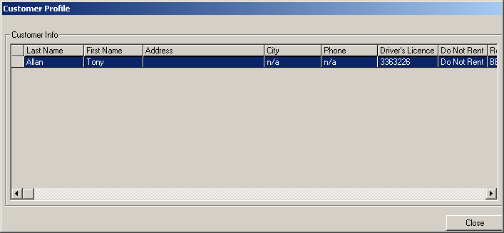
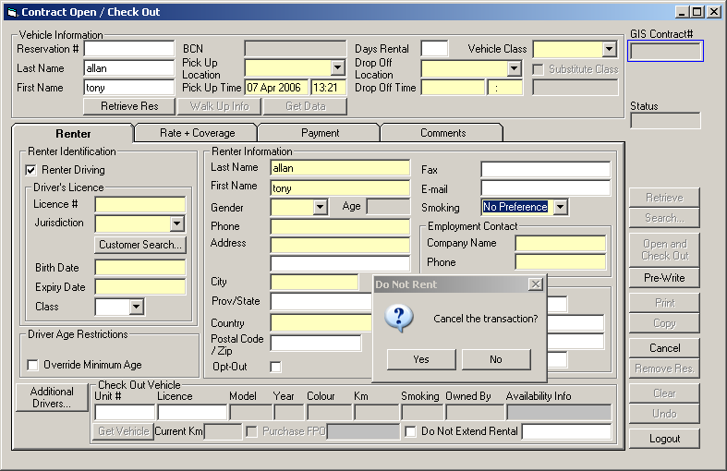

If not all the matches are “Don Not Rent” Customers, CSR can check the customer profile and make selections.

Customer Information Pre-populated:
Apply to: Contract Open, Additional Driver
When CSR Enter customer’s driver license number or customer’s name into GIS system, GIS will use this information to retrieve customer information automatically and pre-populated GIS Contract Open Contract Screen or Additional Driver Screen with these information if there is only one match found. If there are more than one match found, GIS will ignore it.

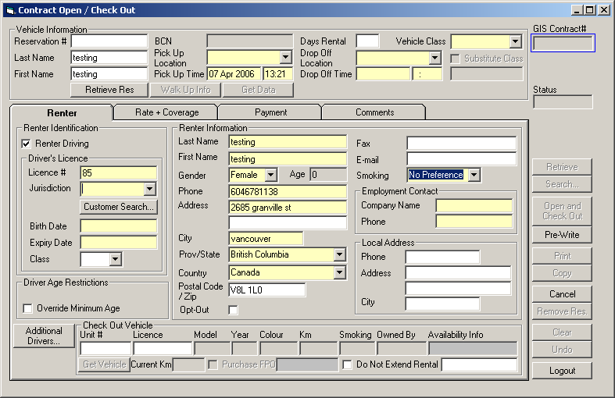
When User types in Driver License number 85, all the other information are pre-populated.

Fraudulent Credit Card Checking:
Apply to: Reservation, Contract Open Main Screen, Reservation, Contract Open, Contract Change during Rental, Contact Check-in, Contract Adjustment, foreign check-in, Deposit Refund Screen.
We maintain a list of Fraudulent Credit Card Numbers in our database. We created a tool for the Admin users to enter these credit cards information into our database.
When user enters the credit card information into GIS system, GIS will check these credit card numbers again the fraudulent credit Card listing. If found match, User will be send to the cancellation windows, with turn down reason of “Fraudulent Credit Card” pre-selected by the system.
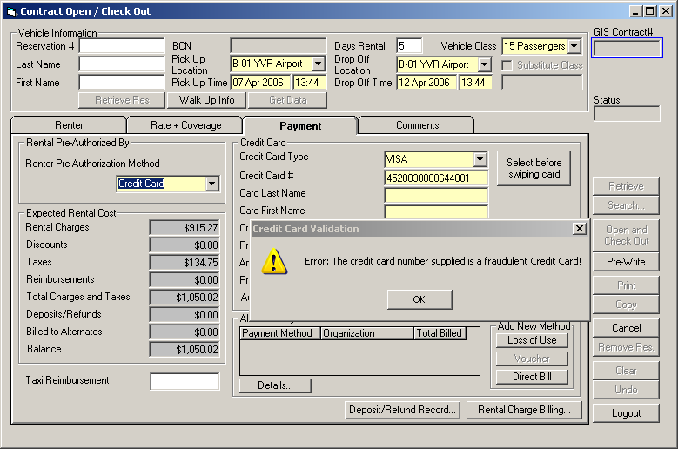
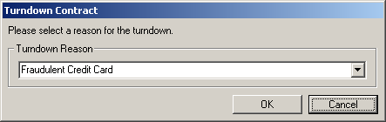

Fraudulent Credit Card Listing Maintenance

User can use this small tool to enter the fraudulent credit card numbers
